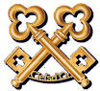

***Unique Art & Wine experience in Tourettes sur Loup***



Leave the Hotel du Cap Eden Roc with your chauffeur and drive to Tourrettes sur Loup (40 mns)

Perched on a rocky outcrop surrounded by superb landscapes where prickly pears grow naturally, the village of Tourrettes sur Loup seems to conquer all beneath it with its tall houses built along its ramparts.  
It's not called "Violet village"for nothing because for over a century this shy pretty flower has been grown in the village.  
Even today it's one of the main activities in the village. The flower is honored each year in March with a flower festival, decorated floats and a flower battle

[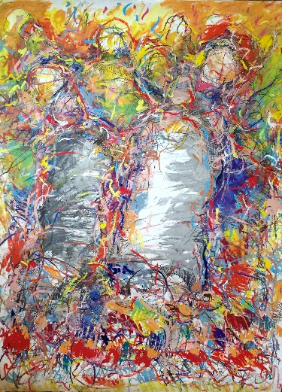](http://ad-hoc-corner.com/portfolio/peinture-sauvage/?portfolioID=7)

[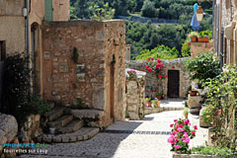](https://www.provenceweb.fr/e/alpmarit/tourtlou/tourtlou.htm)

In this unique 17th century stone village house full of rich history in the living memory of former owners such as Claude Lelouch (famous movie maker) as well as others famous artist, the emotion brings the evidence of sharing Arts with the magnificent beauty and spirit of the place.



In this unique 17th century stone village house full of rich history in the living memory of former owners such as Claude Lelouch (famous movie maker) as well as others famous artist, the emotion brings the evidence of sharing Arts with the magnificent beauty and spirit of the place.

Enjoy a wine degustation by our sommelier Romain who will select a fine category together with a selection of cheese and charcuterie prepared by a one Michelin starred Chef.

Lunch at our sister property Chateau Saint Martin at l’Oliveraie under the olive trees (in supplement)

Visit of the iconic Maeght foundation with your private guide

Return at the Hotel du Cap around 6 pm

[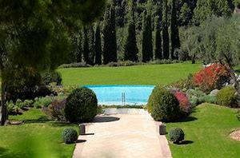](https://www.bing.com/images/search?view=detailV2&ccid=CyQ9gL5c&id=ADACF02CE6FB4C92A70D1ABBDD8C875C2094ACE7&thid=OIP.CyQ9gL5cpDWBlfY08CdQEQHaE8&q=chateau+saint+martin&simid=607998733793298367&selectedIndex=57)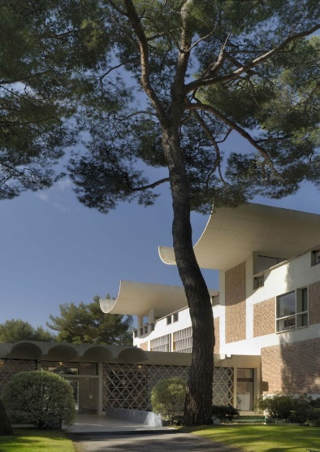

Rate : 2000 € for two persons including your chauffeur and S class Mercedes

Private visit of the Villa & Gallery, wine degustation, private visit of the Maeght Foundation